**VIRTUALEYE-LIFE GUARD FOR SWIMMING POOLS TO DETECT ACTIVE DROWING USING IBM CLOUD**

UG PROJECT PHASE-1 REPORT

Submitted to

**JAWAHARLAL NEHRU TECHNOLOGICAL UNIVERSITY,**

**HYDERABAD**

In Partial fulfilment of the requirements for the award of the degree of

**BACHELOR OF TECHNOLOGY**

**IN**

**COMPUTER SCIENCE AND ENGINEERING**

Submitted by

# ALLA AKHILA 19UK1A0519

# PALAKURTHI NITHIN 19UK1A0521

# KUDURUPAKA ANUSHA 19UK1A0555

**SUSMITHA UPPULA 19UK1A0523**

Under the esteemed guidance of

**Mr. N. Sravan** **Kumar**

(Assistant Professor)



**DEPARTMENT OF COMPUTER SCIENCE AND ENGINEERING** **VAAGDEVI ENGINEERING COLLEGE**

(Affiliated to JNTUH, Hyderabad) Bollikunta,Warangal-506005

**2019-2023**

**DEPARTMENT OF COMPUTER SCIENCE AND ENGINEERING**

**VAAGDEVI ENGINEERING COLLEGE**

**BOLLIKUNTA, WARANGAL –506005**

**2019-2023**



**CERTIFICATE OF COMPLETION** **UG PROJECT PHASE-1**

This is to certify that the UG Project Phase-1 entitled “**VIRTUALEYE-LIFE GUARD FOR SWIMMING POOLS TO DETECT ACTIVE DROWING USING IBM CLOUD”** is being submittedby **A.AKHILA(H.NO:19UK1A0519),U.SUSMITHA(H.NO:19UK1A0 523),P.NITHIN(19UK1A0521),K.ANUSHA(19UK1A0555)** in partial fulfilment of the requirements for the award of the degree of Bachelor of Technology in Computer Science and Engineering to Jawaharlal Nehru Technological University Hyderabad during the academic year 2022-2023,is a record of work carried out by them under the guidance and supervision.

# Project Guide Head of the Department Mr. N. Sravan Dr. R. Naveen Kumar (Assistant professor) (Professor)

**External**

# ACKNOWLEDGEMENT

We wish to take this opportunity to express our sincere gratitude and deep sense of respect to our beloved **Dr.P.PRASAD RAO,** Principal, Vaagdevi Engineering College for making us available all the required assistance and for his support and inspiration to carry out this UG Project Phase-1 in the institute.

We extend our heartfelt thanks to **Dr.R.NAVEEN KUMAR**, Head of the Department of CSE, Vaagdevi Engineering College for providing us necessary infrastructure and thereby giving us freedom to carry out the UG Project Phase-1.

We express heartfelt thanks to Smart Bridge Educational Services Private Limited, for their constant supervision as well as for providing necessary information regarding the UG Project Phase-1 and for their support in completing the UG Project Phase-1.

We express heartfelt thanks to the guide, **Mr.N.SRAVAN KUMAR** Assistant professor, Department of CSE for his constant support and giving necessary guidance for completion of this UG Project Phase-1.

Finally, we express our sincere thanks and gratitude to my family members, friends for their encouragement and outpouring their knowledge and experience throughout the thesis.

**ALLA AKHILA (19UK1A0519)**

**UPPULA SUSMITHA (19UK1A0523)**

**PALAKURTHI NITHIN (19UK1A0521)**

**KUDURUPAKA ANUSHA (19UK1A0555)**

**ABSTRACT**

Every year, many individuals, including kids under the age of 5 drown in the deeps of the swimming pool, and the lifeguards are not well trained enough to handle these situations. Thus arises the requirement for having a system that will consequently detect the drowning individuals and alarm the life guard at such risk. Swimming pool surveillance systems plays an essential role in safeguarding the premises. In this project differential pressure approach is used for detection of drowning incidents in swimming pools at the earliest possible stage. The children’s life is saved during drowning incidents in the swimming pool by lifting the acrylic plate. The proposed approach consists of RF module, Pressure Sensor and Motor Driver. The demo system based on pressure sensor has an advantage of convenience, cost saving and simple algorithm.

**Key Words:** RF module, ATmega32 Microcontroller, Acrylic plate, Pressure sensor, Motor driver.

**TABLE OF CONTENTS:-**

1. **INTRODUCTION**
   1. Overview

A brief description about your project

* 1. Purpose

The use of this project. What can be achieved using this.

1. **LITERATURE SURVEY**
   1. Existing problem

Existing approaches or method to solve this problem

* 1. Proposed solution

What is the method or solution suggested by you?

1. **THEORITICAL ANALYSIS**
   1. Block diagram

Diagrammatic overview of the project.

* 1. Hardware / Software designing

Hardware and software requirements of the project

1. **EXPERIMENTAL INVESTIGATIONS**

Analysis or the investigation made while working on the solution.

1. **FLOWCHART**

Diagram showing the control flow of the solution

1. **RESULT**

Final findings (Output) of the project along with screenshots.

1. **ADVANTAGES & DISADVANTAGES**

List of advantages and disadvantages of the proposed solution

1. **APPLICATIONS**

The areas where this solution can be applied

1. **CONCLUSION**

Conclusion summarizing the entire work and findings.

1. **FUTURE SCOPE**

Enhancements that can be made in the future.

1. **BIBILOGRAPHY**

References of previous works or websites visited/books refered for analysis about the project , solution previous findings etc.

**APPENDIX**

A Source Code

Attach the code for the solution built

**1.INTRODUCTION**

## 1.1 Overview

Virtual Eye is a computer vision detection system for the prevention of drowning incidents in swimming pools .Virtual Eye works like an “extra lifeguard” under the water of your pool. Our object recognition software tracks the movements of all swimmers in a pool. And in the event of a serious drowning incident ,Virtual Eye will provide an alarm to pool lifeguards. This will help lifeguards improve their reaction-time, as they initiate a rescue . The live video stream from our underwater cameras is automatically monitored by our “state-of-the-art” object recognition software .When Virtual Eye detects a swimmer in distress on the bottom of the pool, it will raise a radio alarm to pool lifeguards and an visual alarm to our Monitoring & Control Station. Lifeguards can visually assess the developing situation within seconds of the event first occurring, and initiate their rescue procedure when necessary.

**1.2 Purpose**

Every year, many individuals, including kids under the age of 5 drown in the deeps of the swimming pool, and the lifeguards are not well trained enough to handle these situations. Thus arises the requirement for having a system that will consequently detect the drowning individuals and alarm the life guard at such risk. Swimming pool surveillance systems plays an essential role in safeguarding the premises. In this project differential pressure approach is used for detection of drowning incidents in swimming pools at the earliest possible stage. The children’s life is saved during drowning incidents in the swimming pool by lifting the acrylic plate. The proposed approach consists of RF module, Pressure Sensor and Motor Driver. The demo system based on pressure sensor has an advantage of convenience, cost saving and simple algorithm.

## 2.LITERATURE SURVEY

## 2.1 Existing problem

Swimming pool drowning monitoring system based on video technology is mostly reported in the literature. There are three kinds drowning monitoring system according to the different position of the camera. One is that the camera is mounted on the underwater swimming pool wall, then monitor underwater swimmer status. A limitation of this equipment is that if too many swimmers, the occlusion problem arises. The other is that the camera is mounted upon the water, and monitors the Swimmer posture change. The reflection and refraction of light in air-water interference will affect the image quality, and drowning man feature this method detected is not easy to distinguish swimmers and divers obviously.The third is a combination of the two, underwater camera and aerial camera matched, monitoring the swimmer posture. This system needs constant observation which is the main disadvantage.

**2.2 Proposed solution**

The automated drowning detection system works on the principle of differential pressure. The system contains two fundamental modules: to begin with, the wristband consisting of pressure sensors on the transmitter side. Second, the receiver module at the swimming pool site. The children entering the pool territory should wear the wristband. The Pressure at underwater is different and greater than the pressure at the air - water interface. The pressure at a particular depth is measured and set as the threshold. Once the child gets into the pool, the pressure is continuously measured and monitored by the microcontroller. When the current value surpasses the threshold limit an alerting signal is sent to the receiver. The wireless transmission and reception of signals is done through RF module. On receiving the valid signal microcontroller sets the buzzer ON, turns ON the motor driver which in turn lifts the acrylic plate of the multifloored swimming pool. The kid is brought to air-water interface, i.e.the top level of swimming pool by the acrylic plate.

**3.THEORITICAL ANALYSIS**

**3.1 Block diagram** 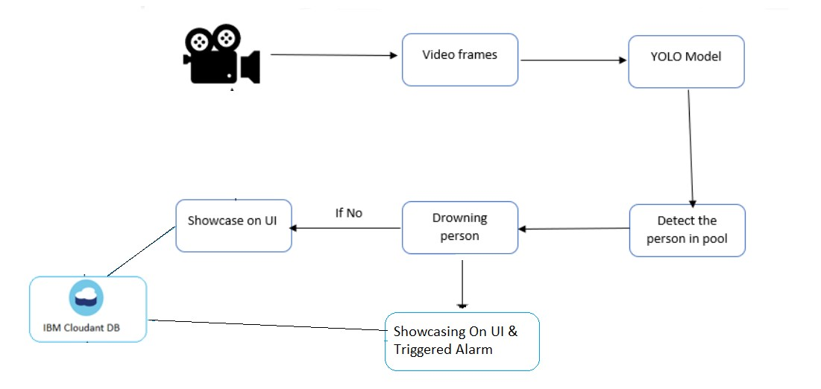

**3.2 Hardware and Software designing**

To complete this project, you must require the following software’s, concepts, and packages. Anaconda Navigator is a free and open-source distribution of the Python and R programming languages for data science and machine learning related applications. It can be installed on Windows, Linux, and macOS. Conda is an open-source, cross-platform, package management system. Anaconda comes with so very nice tools like Jupyter Lab, Jupyter Notebook, QtConsole, Spyder, Glueviz, Orange, R studio, Visual Studio Code. For this project, we will be using Jupyter

notebook and Spyder.

**4.EXPERIMENTAL INVESTIGATION**

The dominant devices of the virtual eye contacts are the cameras (Web-cams are used in general) in the virtual platforms. Besides, live screen parts on the monitors are as important as Web-cams as mentioned before. These two parts generate synchronous virtual eye contacts to be used together with the Internet lines. When using a camera, the screen size, framing of the instructor during shooting, location of the camera, camera height and picture quality effect generating of virtual eye contacts in virtual classroom environments.

There is three important parts on the monitor screen in virtual classroom platforms at the learner side as mentioned. These are presentation screen, live screen and chat-box part. Because of dividing one monitor screen at least these main parts, there is a small place for live screen part. (Generally presentation screen parts take the largest part of the monitor screen because of helping to be explained content parts which cover slide shows, animations, images, written questions or taped motion pictures.) Besides, there is an aspect ratio of the live screen parts like the other parts. The traditional aspect ratio is 4:3 which means 4 wide by 3 high in TV screens. HDTV’s aspect ratio is 16:9. Since there is a live and motion image on it, virtual classroom platform producers tend to use the traditional aspect ratios because of the familiarity of the users from the television screens.

On the other hand, there are always minor aspect ratio and pixel count differences between software programs (Kerlow, 2004). Live screen takes part with a definite aspect ratio in a small part of the client’s monitor. Some virtual classroom platforms allow making the live screen larger; but it does not cover full screen because of the importance of the other screen parts of the virtual classrooms.

This criterion affects framing of the instructor in front of the camera. This communication worker is generally sitting during the virtual classroom. meetings, because she/he uses his or her mouse or keyboard to control and change the content parts or interact with the distance learners both verbally or text-based. Close-up shots or medium close-up shots of the instructor may probably the most appropriate shots for producing virtual eye contacts.

Close-up shot of a person refers just above head to upper chest and medium close-up refers cutting of a body at lower chest (Millerson, 1985). It is possible to see the eyes of the instructor easily for distance learners with these shots. If the framing of that person becomes larger, the head and the eyes will become smaller and because of the small size of the screen, virtual eye contact will not occur.

Location of the camera is also critical because of two different situations. First, the instructor must look at the camera directly to generate virtual eye contacts with the distance learners during the synchronous meetings. Second, there are always important materials like content parts or warnings about a client’s question or comment on the monitor. Besides, controlling the presentation screen, changing the content parts and answering the clients are some of the responsibilities of the instructor. (They can have assistants to share controlling or changing responsibilities in the platforms, if they want.) She/he performs these responsibilities on his or her monitor.

If the instructor can see the monitor and look at the camera at the same time, this point of view provides the best solution in the virtual classrooms. This point of view can be achieved if the camera is located nearly above or below of the monitor. With a clear distance from the monitor about one or one and the half meters, the instructor can see these two items.

Moreover, his/her looking at the camera dominantly and gazing at the monitor with the borders of the point of view help him or her during a meeting when there is a need of virtual eye contact generation. (This situation is explained more clearly in the fallowing parts of the article.)

Location of the camera highlights the height of the camera. As the instructor sits down on a chair in front of the monitor, the camera should be located nearly at the eye level of the instructor. The eye level position can be fixed with raising or lowering the height of the monitor depending on the camera’s position being on the top or down of the monitor. Being the upper side or the lower side of the camera from the eye level does not affect the virtual eye contact.

However, it affects the perceiving of the person in front of the camera and this may affect perceiving of the virtual eye contact indirectly. High shots (higher of the camera20° from the eye-line) can make a subject appear weak, unimportant and inferior (Millerson, 1985).

A person seems to lack the authority with these kinds of shots. This situation affects the reliability of the instructor. Low shots (lower of the camera 20° from the eye-line) make the people appear imposing, threatening and powerful (Millerson, 1985). Threatening position also provides a barrier between the instructor and the distance learners. Therefore, virtual eye contacts will be affected by these camera positions negatively. Eye level shots provide the best solution in the virtual classroom platforms.

The picture quality of the live image is another technical aspect in the side of the distance learners for generating virtual eye contact. Suwita, Bocker, Muhlbach and Runde (1997) state that picture quality of HDTV better than traditional television and there is not a difference between HDTV (High Definition Television) and traditional television for the distance partners in video conference applications about recognizing of non-verbal communications like gestures or postures. This criterion also provides guessing the picture quality of the live screens in virtual classroom platforms for the producers. If the image of the instructor can be seen clearly by the e-learners, this will be enough for generating virtual eye contacts.

There may be different shooting angles of the cameras or the Web-cams which provide the live images without generating virtual eye contact. These kinds of live images are also acceptable in the virtual classrooms. However, shootings with providing virtual eye contacts create further benefits for the distance learners.

**5.FLOWCHART**

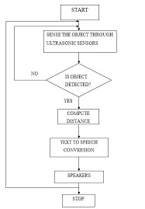

Fig. Flow chart of virtual eye

## 6.RESULT

## we find that the virtual eye expression renders of sadness and anger generated from our model conveyed a significant level of emotional recognition to respondents. Surprise and happiness indicated no statistically meaningful proportional differences in perception. Finally, fear and disgust displayed an adverse level of perception however these scores could be improved with a higher fidelity of the main subtle cues that the audience uses to identify the emotions and conducting a more comprehensive survey which takes into account respondent's racial identity.

## 7.ADVANTAGES AND DISADVANTAGES

**Advantages:**

1.Potential benefits to patient safety and ethical acceptability.

2.Opportunity to assess trainee competence in a consistent and reproducible manner.

3.Low risk environment in which trainees can practice at any time.

4.Predictable availability regardless of external factors.

5.Emerging evidence of construct validity and transferability of simulator skills.

**Disadvantages:**

1.Nascent technology with imperfect fidelity.

2.Expensive to implement.

3.Limited evidence regarding optimal implementation within residency training.

4.Limited to certain procedures.

5.Current simulators only focus on developing technical skill and do not incorporate interaction with the rest of the intraoperative team.

**8.APPLICATIONS**

-Perception

-Sonification techniques

-Training

-Sensor emulation and hardware integration

**Output images:**

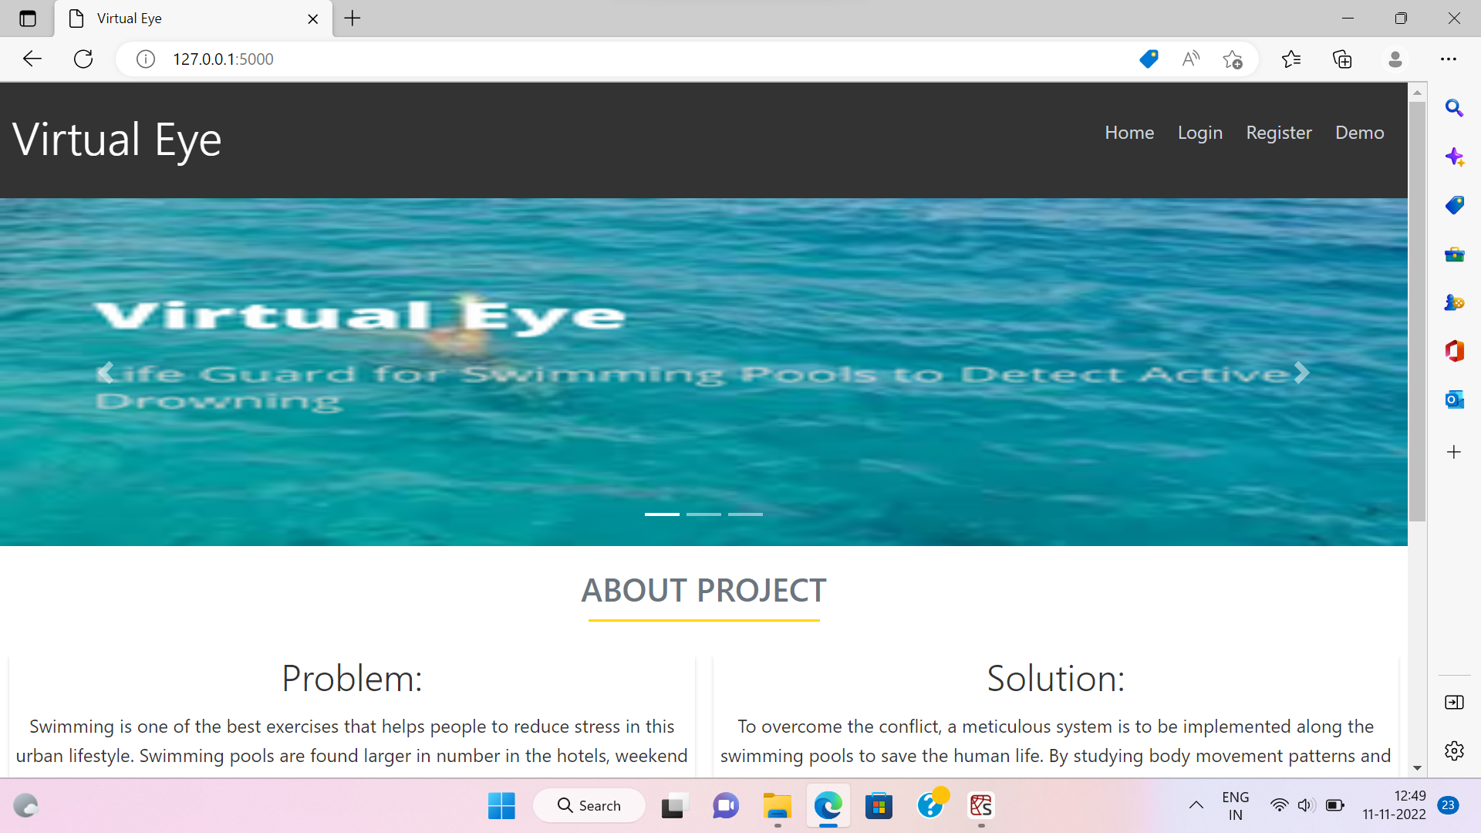







**9.CONCLUSION**

Consistently numerous people, including kids, are suffocated or near suffocating in the deeps of the swimming pools, and the lifeguards are not prepared all around to deal with these issues. In this manner raises the necessities for having a framework that will thus recognize the suffocating people and alert the lifeguards at such hazard. It can be installed in International standardized schools where classes are held for training kids.

**10.FUTURE SCOPE**

Future work will be focused on enhancing the performance of the system and reducing the load on the user by adding the camera to guide the blind exactly. Images acquired by using web camera and NI-smart cameras helps in identification of objects as well as scans the entire instances for the presence of number of objects in the path of the blind person. It can also detect the material and shape of the object. Matching percentage has to be nearly all the time correct as there no chance for correction for a blind person if it is to be trusted and reliable one. The principles of mono pulse radar can be utilized for determining long range target objects. The other scope may include a new concept of optimum and safe path detection based on neural networks for a blind person.

**11.BIBILOGRAPHY**

[1] Amjed S. Al-Fahoum, Heba B. Al-Hmoud, and Ausaila A. Al Fraihat, “A Smart Infrared Microcontroller-Based Blind Guidance System”, Hindawi Transactions on Active and Passive Electronic Components,Vol.3, No.2, pp.1-7, June 2013.

[2] Harshad Girish Lele, Viten Vilas Lonkar, Varun Vasant Marathe and Mrunmayi Mohan Modak, “Electronic Path Guidance for Visually Impaired People”, The International Journal Of Engineering And Science (IJES), Vol.2, No.4, pp.9-12, April 2013.

[3] Pooja Sharma, Mrs. Shimi S. L. and Dr. S.Chatterji, “Design of microcontroller based Virtual Eye for the Blind”, International Journal of Scientific Research Engineering & Technology (IJSRET), Vol.3, No.8, pp.1137-1142, November 2014.

[4] Pooja Sharma, Mrs. Shimi S. L. and Dr. S.Chatterji, “A Review on Obstacle Detection and Vision”, International Journal of Engineering Sciences and Research Technology”, Vol.4, No.1, pp. 1-11, January 2015.

[5] Naseer Muhammad and Engr.Qazi Waqar Ali, “Design of Intelligent Stick Based on Microcontroller with GPS Using Speech IC”, International Journal of Electrical and Computer Engineering (IJECE) Vol.2, No.6, pp. 781~784 , December 2012.

[6] K.Chandana and G.R.Hemantha, “Navigation for the Blind Using GPS along with Portable Camera Based Real Time Monitoring”, SSRG International Journal of Electronics and Communication Engineering (SSRG-IJECE), Vol.1 No.8, pp. 46-50, Oct 2014.

[7] M. Naveen Kumar and K. Usha, “Voice Based Guidance and Location Indication System for the Blind Using GSM, GPS and Optical Device Indicator”, International Journal of Engineering Trends and Technology (IJETT), Vol.4 No.7, pp. 3083-3085, July 2013.

[8] Harsha Gawari and Prof. Meeta Bakuli, “Voice and GPS Based Navigation System For Visually Impaired”, International Journal of Engineering Research and Applications”, Vol. 4, No. 4, pp. 48-51, April,2014.

[9] Dr. Boyina. S. Rao, Ms. K.Deepa, Hari Prasanth.L, Vivek.S, Nanda Kumar.S, Rajendhiran.A and Saravana. J, “Indoor Navigation system for Visually impaired person using GPS”, International journal of Advanced Engineering and Technology, Vol.3 No.2, pp. 40-43, April-June, 2012.

[10] Rupali Kale and A. P.Phatale, “Design of a GPS based Virtual Eye for the Blind People”, International Journal of Current Engineering and Technology, Vol.4, No.3, pp. 2162-2164, June 2014.

[11] G.Gayathri, M.Vishnupriya, R.Nandhini and Ms.M.Banupriya, “Smart Walking Stick for visually impaired”, International Journal Of Engineering And Computer Science, Vol.3, No.3, pp. 4057- 4061, March, 2014.

[12] Dr. Boyina. S. Rao, Ms. K.Deepa, Hari Prasanth.L, Vivek.S, Nanda Kumar.S, Rajendhiran.A and Saravana. J, “Indoor Navigation system for Visually impaired person using GPS”, International journal of Advanced Engineering and Technology, Vol.3 No.2, pp. 40-43, April-June, 2012.

[13] Saneesh. C. T, Deepashree. A. V, Gagana Divya and Trupti Agrawal, “Safety Guard for Blind using 8051”, Proceedings of ASAR International Conference, Mysore, India, pp. 43-44, May 14, 2014.

[14] B.Amutha and M.Ponnavaikko, “Location Update Accuracy in Human Tracking system using Zigbee modules”, International Journal of Computer Science and Information Security, Vol. 6, No. 2, pp. 322-331, 2009.

[15] Przemyslaw Baranski, Maciej Polanczyk and Pawel Strumillo, “A Remote Guidanc System for the Blind”, IEEE Transactions on Remote Guidance, pp. 386-390, June 2010.

[16] Bruce Moulton, “Voice Operated Guidance Systems for Vision Impaired People: Investigating a User-Centered Open Source Model”, International Journal of Digital Content Technology and its Applications, Vol. 3, No. 4, pp. 60-68, December 2009.

[17] Megha Agarwal and Dr.S.R.N.Reddy, “Low Frequency RFID Based Object Identification System for Blind People: RFASSIST”, International Journal of Emerging Trends in Electrical and Electronics (IJETEE), Vol. 3, No,.2, pp. 20-28, May,2013.

[18] Abhishek Choubey and Dattatray Patil, “To Design RFID Based Cognition Device for Assistance to Blind and Visually Challenged Personal for Indoor Use”, International Journal of Engineering and Innovative Technology (IJEIT), Vol.1, No.6, pp. 70-72, June 2012.

[19] M. Mathankumar and T. Kavitha, “Design and Implementation of Smart Supermarket System for Vision Impaired”, International Journal of Engineering and Technology (IJET), Vol.5 No.1, pp. 215- 219, feb-mar 2013.

[20] Elif Aydın, Rusen Öktem, Zeynep Dinçer, Kaan Akbulut,” Study of an RFID Based Moving Object Tracking System”, IEEE Conference on 1st annual RFID Eurasia, 2007.

[21] Ersin BAL, “An RFID Application for the disabled: Path Finder”, IEEE Conference on 1st annual RFID Eurasia, 2007.

[22] HarioBazzani, Enzo H. Humolo, “PC-based telephone communication system for deaf-blind people,” IEEE Conference, vol.1, 43-47, 1988.

[23] Honglian Li, Baozong Yuan,” Research on Voice Browsing”, proceedings of IEEE, TENCON, 2002.

[24] Lorenzo Faggion, Graziano Azzalin,” Low-Frequency RFID Based Mobility Network for Blind People: System Description, Evolutions and Future Developments”, IEEE International Conference on RFID-Technologies and Applications, 2011.

[25] Martin Brandl Julius Grabner, Karlheinz Kellner, Franz Seifert, Johann Nicolics, Sabina Grabner, and Gerald Grabner,” A Low-Cost Wireless Sensor System and Its Application in Dental Retainers”, IEEE sensors journal, vol. 9, no. 3, March 2009.

[26] Meenakshi Sharma, Adil Siddiqui,” RFID Based Mobiles: Next Generation Applications”, the 2nd IEEE International Conference on Information Management and Engineering (ICIME), 2010.

[27] Mohsin Murad, Abdullah Rehman, Arif Ali Shah, Salim Ullah, Muhammad Fahad, Khawaja M. Yahya,” RFAIDE – An RFID Based Navigation and Object Recognition Assistant for Visually Impaired People”, 7th International Conference on ICET, 2011.

[28] Muhammad Muazzem Hossain and Victor R. Prybutok” Consumer Acceptance of RFID Technology: An Exploratory Study”, IEEE transanctions on engineering management, Vol. 55, No. 2, May 2008.

[29] N. Krahnstoever, J. Rittscher, P. Tu, K. Chean, T. Tomlinson,” Activity Recognition using Visual Tracking and RFID”, proceedings of 7th IEEE, WACV/MOTION, 2005.

[30] Vasileios Lakafosis, Rushi Vyas, Symeon Nikolaou,” Progress Towards the First Wireless Sensor Networks Consisting of Inkjet Printed, Paper-Based RFID-Enabled Sensor Tags”, proceedings of the IEEE, Vol. 98, No. 9, September 2010.

[31] S.Bharathi, A.Ramesh, S.Vivek and J. Vinoth Kumar, “Effective Navigation for Visually Impaired by Wearable Obstacle Avoidance System”, International Journal of Power Control Signal and Computation (IJPCSC), Vol.3, No.1, pp. 51-53, January-March 2012.

[32] Shraga Shovel, Iwan Ulrich, and Johann Borenstien, “NavBelt and the Guide Cane”, IEEE Transactions on Robotics & Automation, Vol.10, No.1, pp. 9-20, March 2003.

[33] D. Yuan and R. Manduchi, “Dynamic Environment Exploration Using a Virtual White Cane”, Proceedings of the IEEE Computer Society Conference on Computer Vision and Pattern Recognition (CVPR), University of California, Santa Cruz, pp. 1-7, 2005.

[34] J. M, Benjamin, N. A. Ali, and A. F. Schepis, “A laser cane for the blind”, Proceedings of San Diego Medical Symposium, pp. 443-450, 1973.

[35] S. Innet and N. Ritnoom, “An Application of Infrared Sensors for Electronic White Stick”, Proceedings of the IEEE International Symposium on Intelligent Signal Processing and Communication Systems Swissôtel Le Concorde,Bangkok, Thailand, pp. 1-4, 2008.

[36] Sylvain Cardin, Daniel Thalmann and Frederic Vexo, “Wearable Obstacle Detection System for visually impaired People”, Ecole Polytechnique Fédérale de Lausanne (EPFL) CH-1015 Lausanne, Switzerland, pp. 1-6.

[37] Maroof H. Choudhury, Daniel Aguerrevere and Armando B. Barreto, “A Pocket PC Based Navigational Aid for Blind Individuals”, Proceedings of the IEEE Intemational Conference on Virmal Environments, Human-Computer Interfaces, And Measurement Systems, Boston, MA, USA, pp. 43-48, July 12-14, 2004.

[38] V. Ramya, Laxmi Raja and B Palaniappan, “Voice Assisted Embedded Navigation System for the Visually Impaired”, International Journal of Computer Applications, Vol.64 No.13, pp. 42-48, February 2013.

[39] B. P. Santosh Kumar, S. Shafiulla Basha and C. Hariprasad, “Guided Microcontroller for Blind People”, International Journal of VLSI and Embedded Systems-IJVES, Vol.3 No.3, pp. 143-147, July-August 2012.

[40] Osama Bader AL-Barrm and Jeen Vinouth, “3D Ultrasonic Stick for Blind”, International Journal of Latest Trends in Engineering and Technology (IJLTET), Vol.3 No.3, pp. 108-114, January 2014.

[41] Akella.S.Narasimha Raju, S.M.K.Chaitanya and Vundavalli Ravindra, “Electronic Travel Aid for Amaurotic People”, International Journal of Engineering Research & Technology (IJERT) Vol.1 No.4, pp. 01-05, June 2012.

[42] Sushant Mahalle and Himanshu lokhande, “Ultrasonic Spectacles & Waist- Belt for Visually Impaired & Blind Person”, IOSR Journal of Engineering (IOSRJEN), Vol.2 No. 4, pp. 46-49, February, 2014.